**Primary Care (PCL, PCM, Adol) Well Child High ED Use (3+) with Low Resource Use**

Call:

glm(formula = High.ED.Utilization.3.Indicator ~ Age.Group + Problem.Count +

CCC.Congenital + CCC.Hem.Imm + CCC.Malignancy + CCC.Metabolic +

CCC.Renal + Public.or.Private.Metric + Holiday.Indicator +

Cerebral.Palsy.DX + Developmental.Disorders.Group.DX + Fractures.DX +

Nausea.and.Vomiting.DX + Last.Primary.Care.Specialty.Seen +

Prior.ED.Visit.Count.Orig + Gender + Major.Region + Race.and.Ethnicity.Group,

family = binomial(logit), data = EDPredictorsLowusePC.2016.df)

Deviance Residuals:

Min 1Q Median 3Q Max

-2.7734 -0.3661 -0.2117 -0.1103 2.9275

Coefficients:

Estimate Std. Error z value Pr(>|z|)

(Intercept) -3.420e+01 2.029e+03 -0.017 0.986554

Age.Group1 thru 3 years -1.672e+00 3.069e-01 -5.449 5.07e-08 ***

Age.Group13 years or more -2.421e+00 5.863e-01 -4.129 3.65e-05 ***

Age.Group3 thru 11 months -5.445e-01 3.028e-01 -1.798 0.072186 .

Age.Group4 thru 12 years -2.215e+00 3.555e-01 -6.232 4.61e-10 ***

Problem.Count 8.403e-02 2.444e-02 3.439 0.000584 ***

CCC.Congenital -2.570e+00 7.879e-01 -3.261 0.001109 **

CCC.Hem.Imm -1.221e+00 6.590e-01 -1.852 0.063959 .

CCC.Malignancy 1.656e+00 9.153e-01 1.809 0.070412 .

CCC.Metabolic -1.769e+01 1.054e+03 -0.017 0.986603

CCC.Renal -1.349e+00 7.983e-01 -1.689 0.091137 .

Public.or.Private.MetricPublic -7.200e-02 4.414e-01 -0.163 0.870438

Public.or.Private.MetricUnavailable 1.454e+00 6.541e-01 2.223 0.026204 *

Holiday.Indicator 1.075e+00 4.382e-01 2.454 0.014125 *

Cerebral.Palsy.DX 1.951e+01 1.158e+03 0.017 0.986559

Developmental.Disorders.Group.DX -1.572e+01 1.158e+03 -0.014 0.989174

Fractures.DX -1.983e+02 1.316e+07 0.000 0.999988

Nausea.and.Vomiting.DX -1.111e+00 5.149e-01 -2.158 0.030949 *

Last.Primary.Care.Specialty.SeenPEDIATRICS/PRIMARY CARE 1.808e+01 1.261e+03 0.014 0.988562

Last.Primary.Care.Specialty.SeenPrimary Care-MEHC 1.803e+01 1.261e+03 0.014 0.988592

Prior.ED.Visit.Count.Orig 7.752e-01 6.375e-02 12.160 < 2e-16 ***

GenderM -3.370e-01 1.976e-01 -1.706 0.088000 .

Major.RegionLocal -3.188e+00 9.449e-01 -3.374 0.000740 ***

Major.RegionNational -1.749e+01 2.585e+03 -0.007 0.994599

Major.RegionRegional -1.979e+01 2.637e+03 -0.008 0.994011

Major.RegionUnknown -2.027e+01 1.075e+04 -0.002 0.998496

Race.and.Ethnicity.GroupBlack or African American 1.706e+01 1.590e+03 0.011 0.991437

Race.and.Ethnicity.GroupHispanic or Latino 1.764e+01 1.590e+03 0.011 0.991146

Race.and.Ethnicity.GroupOther 1.676e+01 1.590e+03 0.011 0.991588

Race.and.Ethnicity.GroupWhite 1.667e+01 1.590e+03 0.010 0.991632

---

Signif. codes: 0 ‘***’ 0.001 ‘**’ 0.01 ‘*’ 0.05 ‘.’ 0.1 ‘ ’ 1

(Dispersion parameter for binomial family taken to be 1)

Null deviance: 1129.01 on 1940 degrees of freedom

Residual deviance: 775.01 on 1911 degrees of freedom

AIC: 835.01

Number of Fisher Scoring iterations: 18

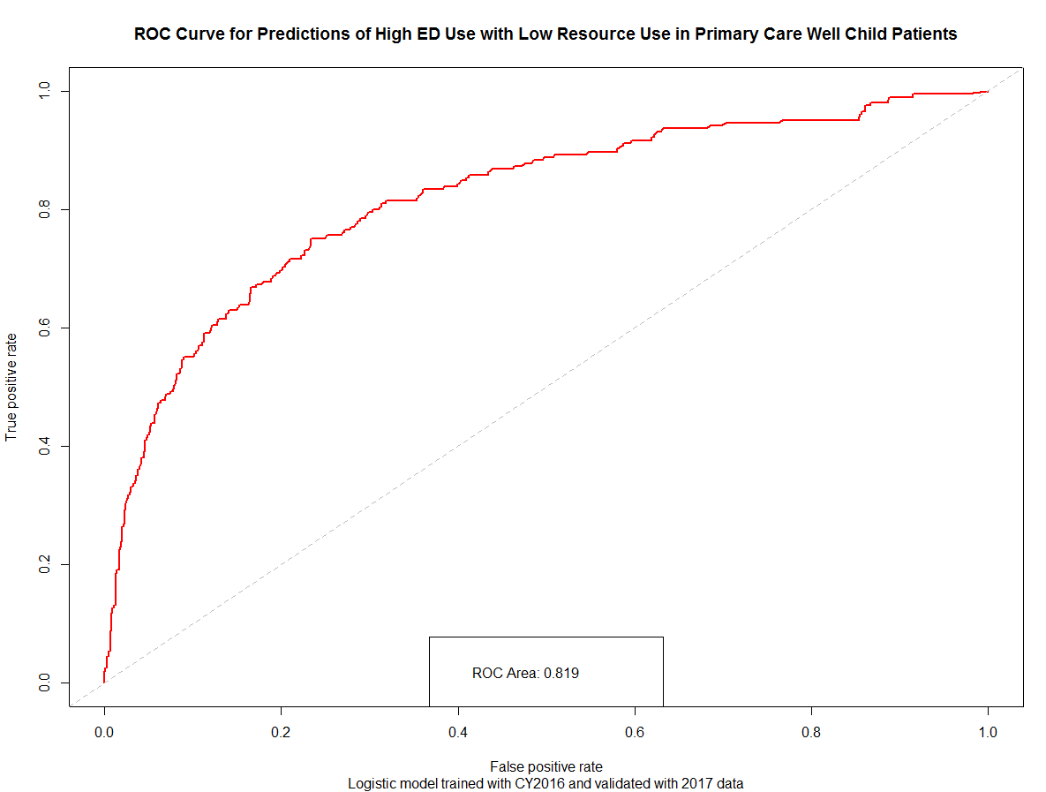

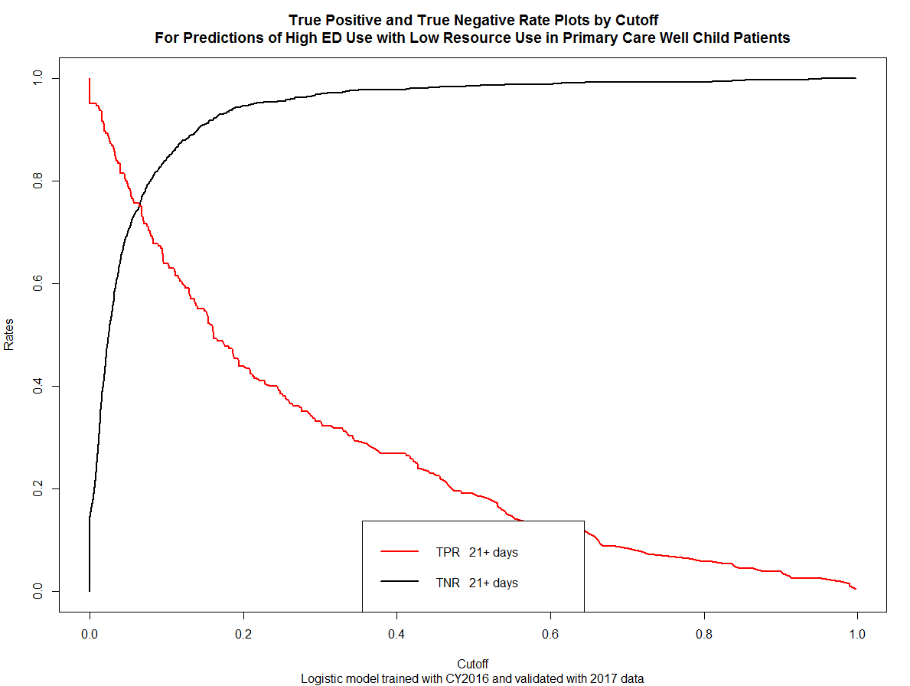

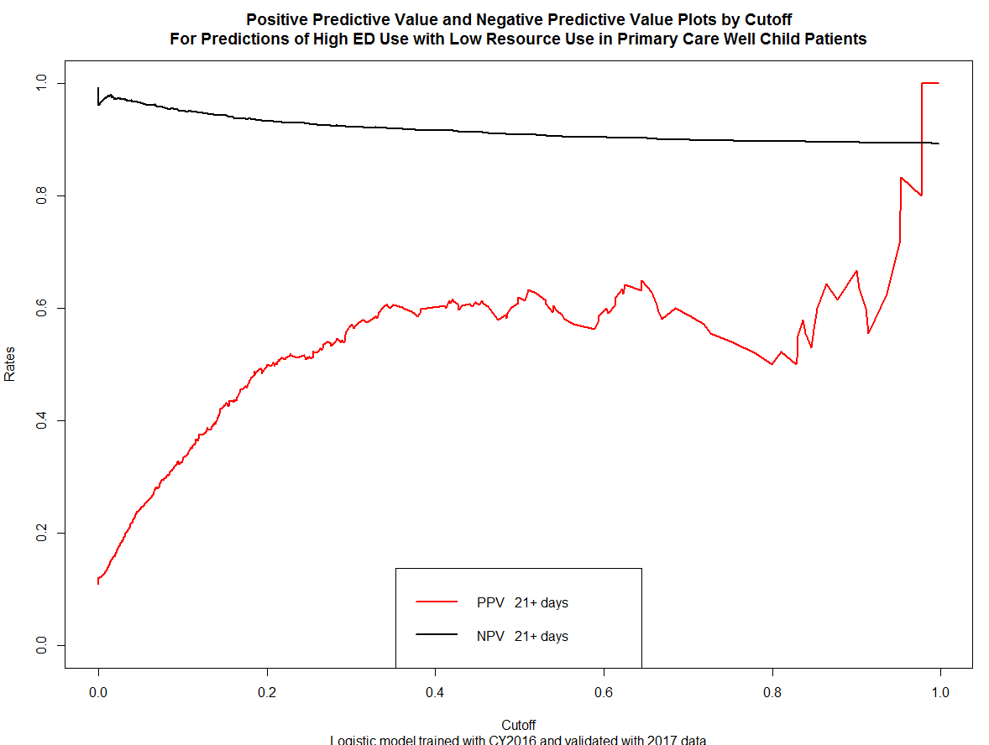

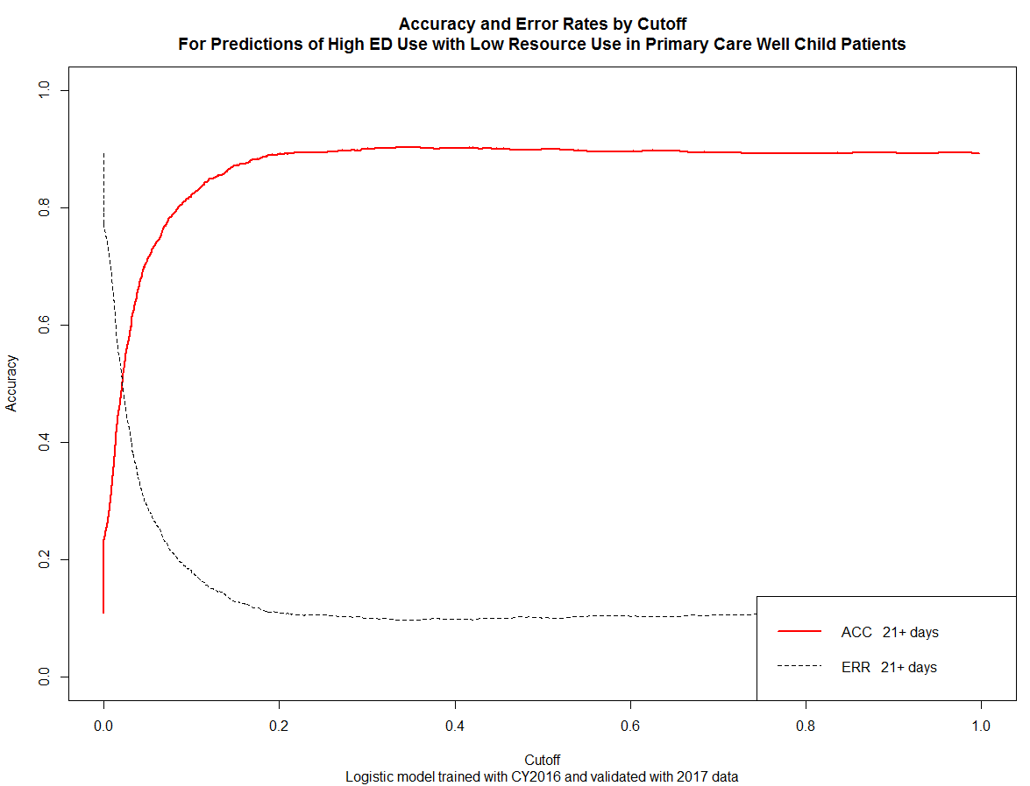

**Previous Version for Review:**

Call:

glm(formula = High.ED.Utilization.Indicator ~ Developmental.Disorders.DX +

Asthma.DX + ADHD.DX + Allergics.Group.DX + Atopic.Dermatitis.DX +

Trauma.Group.DX + Developmental.Disorders.Group.DX + Age.Group +

Problem.Count + CCC.Count + CCC.Congenital + CCC.Neonatal +

CCC.Neuromuscular + Public.or.Private.Metric + Holiday.Indicator +

Long.Term.Drug.Therapy.DX + Major.Region + Race.and.Ethnicity.Group,

family = binomial(logit), data = EDPredictorsLowusePC.2016.df)

**Deviance Residuals:**

**Min 1Q Median 3Q Max**

**-2.3722 -0.7222 -0.4989 -0.2790 2.7313**

Coefficients:

Estimate Std. Error z value Pr(>|z|)

(Intercept) -1.82797 0.51810 -3.528 0.000418 ***

Developmental.Disorders.DX 3.79044 1.26238 3.003 0.002677 **

Asthma.DX 2.18014 0.92474 2.358 0.018395 *

ADHD.DX 4.91978 1.38457 3.553 0.000380 ***

Allergics.Group.DX -1.70297 0.92049 -1.850 0.064304 .

Atopic.Dermatitis.DX 1.77362 1.03446 1.715 0.086429 .

Trauma.Group.DX -0.69519 0.38405 -1.810 0.070272 .

Developmental.Disorders.Group.DX -5.23553 1.46575 -3.572 0.000354 ***

Age.Group1 thru 3 years -0.06150 0.15178 -0.405 0.685346

Age.Group13 years or more -1.34560 0.21622 -6.223 4.86e-10 ***

Age.Group3 thru 11 months 0.25007 0.16188 1.545 0.122401

Age.Group4 thru 12 years -1.30875 0.17384 -7.529 5.13e-14 ***

Problem.Count 0.12885 0.01218 10.577 < 2e-16 ***

CCC.Count 0.19527 0.07052 2.769 0.005624 **

CCC.Congenital -0.50980 0.20863 -2.443 0.014546 *

CCC.Neonatal -0.65868 0.34690 -1.899 0.057597 .

CCC.Neuromuscular -0.28912 0.20483 -1.412 0.158089

Public.or.Private.MetricPublic 0.53020 0.18394 2.882 0.003946 **

Public.or.Private.MetricUnavailable 0.82774 0.34023 2.433 0.014979 *

Holiday.Indicator 0.33307 0.22906 1.454 0.145924

Long.Term.Drug.Therapy.DX 0.37745 0.11674 3.233 0.001223 **

Major.RegionLocal -1.00157 0.37709 -2.656 0.007906 **

Major.RegionNational -2.08627 0.98812 -2.111 0.034742 *

Major.RegionRegional -2.52554 0.84570 -2.986 0.002823 **

Major.RegionUnknown -0.41421 1.38143 -0.300 0.764299

Race.and.Ethnicity.GroupBlack or African American

0.58354 0.39129 1.491 0.135882

Race.and.Ethnicity.GroupHispanic or Latino

0.98100 0.38688 2.536 0.011224 *

Race.and.Ethnicity.GroupOther 0.43654 0.40261 1.084 0.278243

Race.and.Ethnicity.GroupWhite 0.13516 0.45240 0.299 0.765122

---

Signif. codes: 0 ‘***’ 0.001 ‘**’ 0.01 ‘*’ 0.05 ‘.’ 0.1 ‘ ’ 1

(Dispersion parameter for binomial family taken to be 1)

**Null deviance: 4161.0 on 3982 degrees of freedom**

**Residual deviance: 3627.6 on 3954 degrees of freedom**

**AIC: 3685.6**

**Number of Fisher Scoring iterations: 5**

